IEMEC
Lifting Basket

Introduction
Our target with this project is to help aged people to overcome architectural barriers in one of Lisboa neighborhood, known as Mouraria. To know more about specific problems in Mouraria we went there to know what the local population complained about. So, first we did a set of questions to the local residents in order to know their opinion about the subject. We concluded that the elderly had major problems in carrying their shopping bags or other cargo upstairs. In Mouraria there’s lots of big stairways so we noticed that those people needed urgently a system to help them carry their shopping.
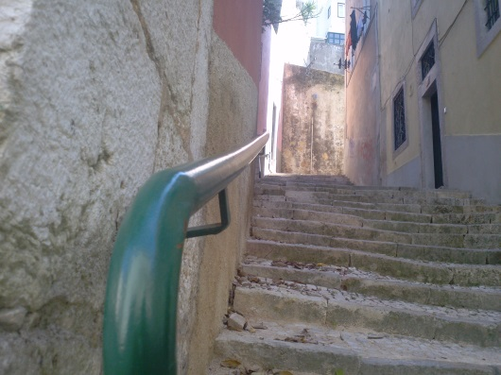
Below are some images, that we shot in Mouraria, of sets of stairs which are a major problem for elder people and where our device could be applied.
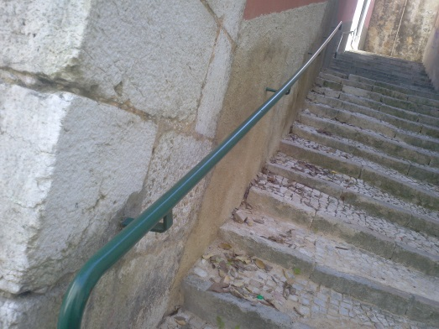

Talking to the local population

One of the most important parts when conceiving a project for a local population is exactly to talk with them, and that’s what we did. We went to Mouraria and talked to the population and the general consensus was that the stairs are a pretty part of Mouraria but to the people who live there it’s one of the obstacles when transporting cargo, specially among elder people. When talking to the elderly we came to the conclusion that the overall need was to have something that would help them transporting their stuff and reducing the effort done when doing it.

Conceptualization
After thinking about these issues, it came across our mind a device that would support the cargo and could be a support for the elder that would be attached to the handrails. The main idea of our project is to perform something simple, cheap and reliable that allows transporting weights through stairs, as shopping things. To achieve this target we will use a mechanical engineering solution. The concept is: a metal basket suspended on the handrail by bearings.
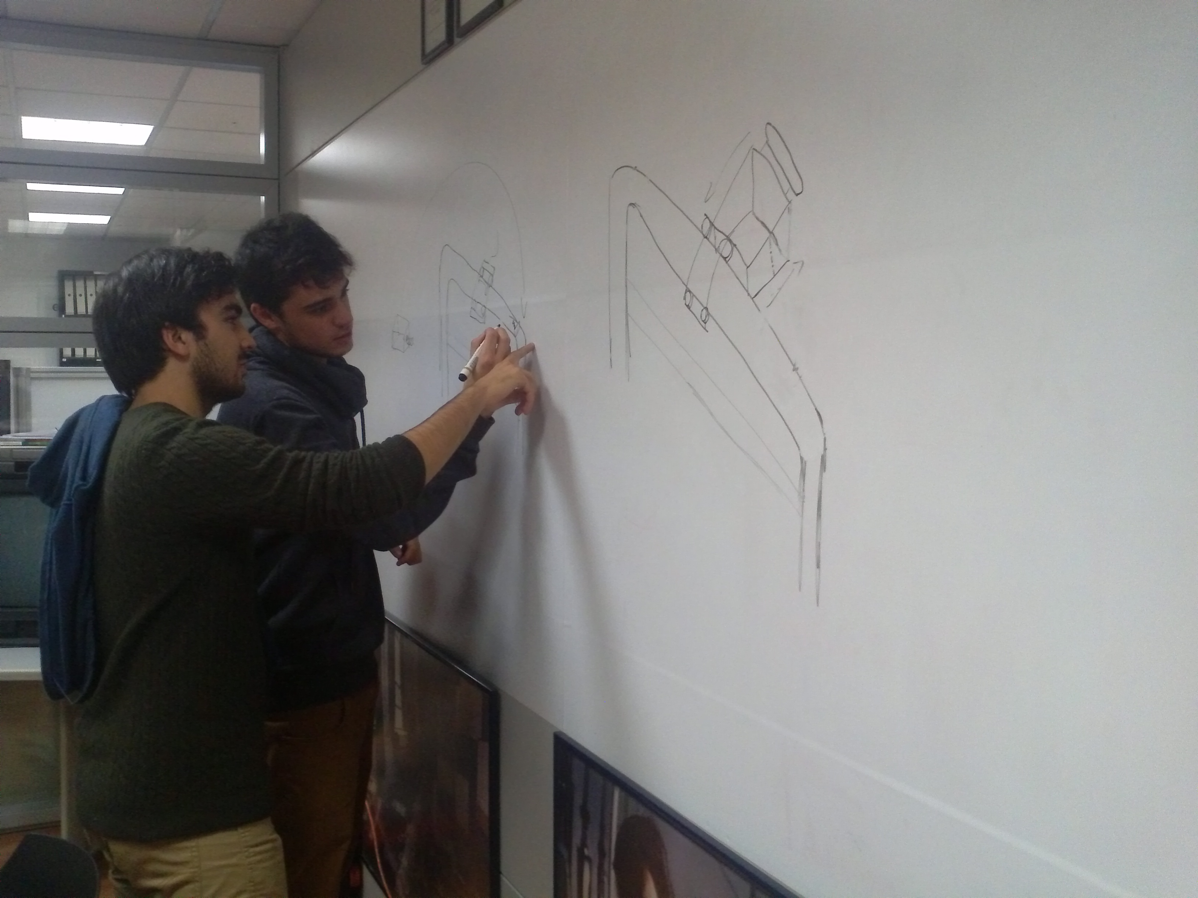
So this system will allow pedestrian to use the handrail freely. The basket will have a relative distance from the wall because it will be installed in the opposite side in order to not interfere with it. A possible problem could be the weight to be transported, which would interfere with the stability of the mechanical device. Thus, we thought about using a brake device similar to the bicycles ones.
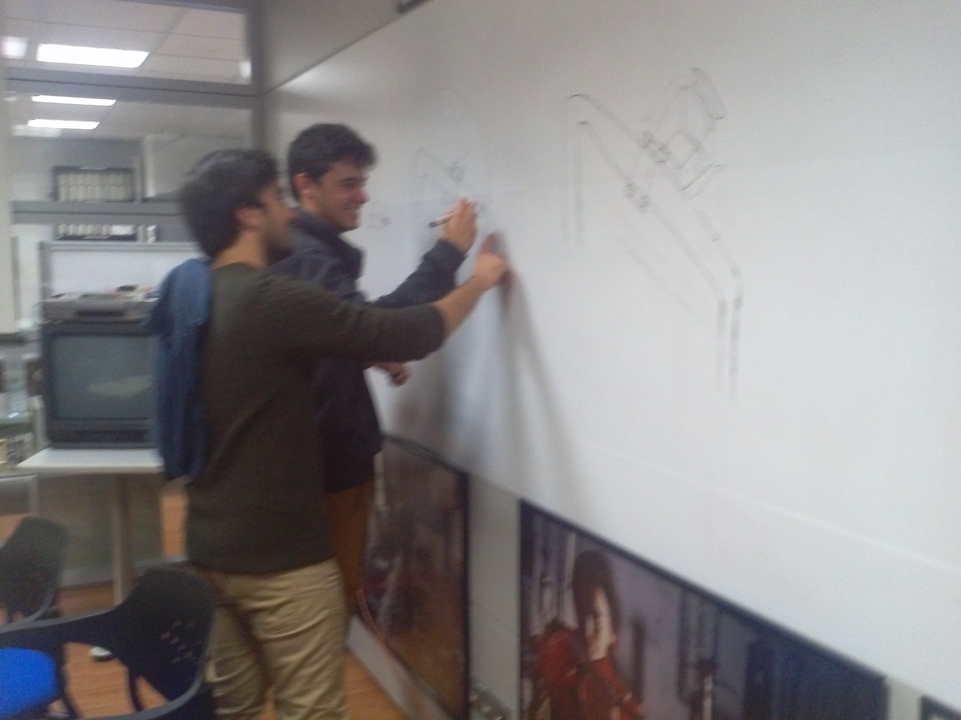

Mechanical Device
In order to accomplish our idea we needed a kind of rail system that would allow the device to slide up and down the rail accordingly to the person’s intentions. So we thought about using wheels and bearings attached to the handrail to solve this problem, in this way it could slide on it and make the transportation of the cargo easier.
The metal basket would be attached to the part of the device that slides on the handrail so people could put their cargo there and just push it up the handrail. We did some calculations about this and we come to the conclusion that with almost little effort the person could transport the cargo upstairs much easier than just carrying it, so people could push their cargo without putting a huge amount of effort.

Issues

To accomplish our idea we had several issues along the way, one of the main issues was the balance of the device. How would the device be balanced on the top of the handrails? To answer this question we need to distinguish different scenarios:
Case 1:
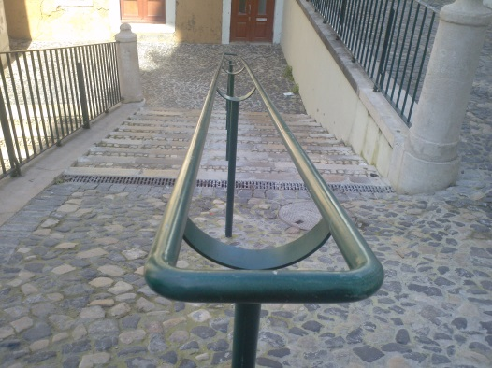
- This handrail doesn’t need a counterweight because we could put easily the basket on the top of the two sliding parts (each one in both sides of the handrail), so the balance wouldn’t be an issue in this type of handrails.

Case 2:
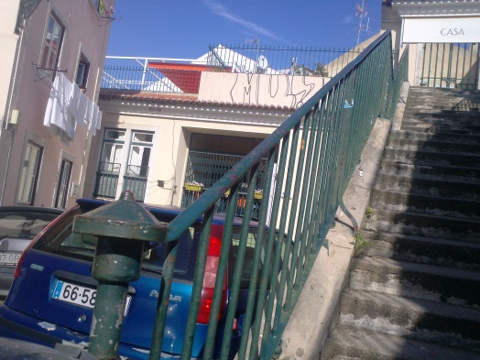
On the otherhand in order to apply our idea to these type of handrails that are mainly just one straight piece (shown on the left) we would need a counterweight to balance the basket, however after thinking seriously about this issue we came up with the idea of making a parallel handrail that would be applied on the staircases so our device could have an extra support instead of a counterweight that would improve the effort that people would have to do.

Conclusion
With this project we came to the conclusion that engineering can help society in a lot of different ways and by talking to people we concluded that a lot of social problems in a local population can be solved with a good engineering idea and that was our main goal. After realizing one of the main issues in Mouraria, we went there, talked to the local residents and came up with a solution for the problem. Our initial idea had some main obstacles and issues but we managed to find a solution for them. Our device can be applied to a huge amount of handrails and help the people transporting their cargo without doing much effort.
This project was good to us to know more about mechanical engineering and how that affects the population.

End

João Ferreira nº 79738
João Gaspar nº

